SELECT names

1. SELECT name FROM world

WHERE name LIKE 'Y%'  
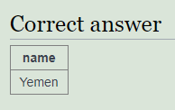

1. SELECT name FROM world

WHERE name LIKE '%y'

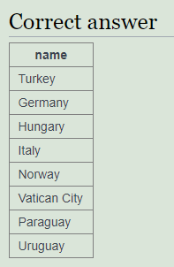

1. SELECT name FROM world

WHERE name LIKE '%x%'

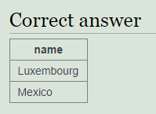

1. SELECT name FROM world

WHERE name LIKE '%land'

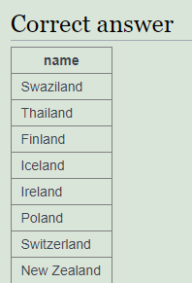

1. SELECT name FROM world

WHERE name LIKE 'C%ia'

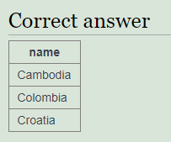

1. SELECT name FROM world

WHERE name LIKE '%oo%'

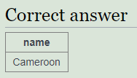

1. SELECT name FROM world

WHERE name LIKE '%a%a%a%'

|  |
| --- |
| **name** |
| Central African Republic |
| Equatorial Guinea |
| Madagascar |
| Mauritania |
| Tanzania |
| Afghanistan |
| Azerbaijan |
| Malaysia |
| Saudi Arabia |
| United Arab Emirates |
| Antigua and Barbuda |
| Bahamas |
| Jamaica |
| Trinidad and Tobago |
| Albania |
| Bosnia and Herzegovina |
| Kazakhstan |
| Canada |
| Guatemala |
| Nicaragua |
| Panama |
| Australia |
| Marshall Islands |
| Micronesia, Federated States of |
| Papua New Guinea |
| Paraguay |
| Saint Vincent and the Grenadines |

1. SELECT name FROM world

WHERE name LIKE '_t%'

ORDER BY name

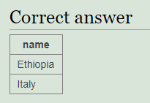

1. SELECT name FROM world

WHERE name LIKE '%o__o%'

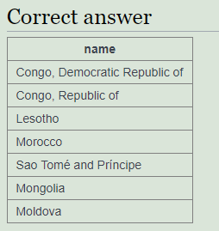

1. SELECT name FROM world

WHERE name LIKE '____'

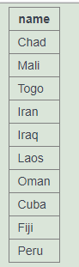

1. SELECT name

FROM world

WHERE name = capital

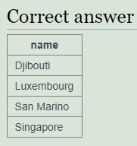

1. SELECT name

FROM world

WHERE capital = concat(name, ' City');

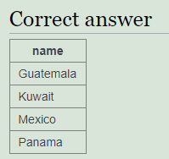

1. select capital, name

from world

where capital like concat ('%',name,'%')

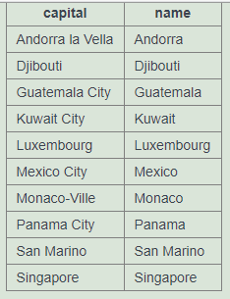

1. select capital, name

from world

where capital like concat ('%',name,'%')

and capital > name  
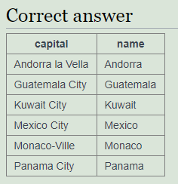

1. SELECT name, REPLACE(capital, name, '') as ext

FROM world

WHERE capital LIKE concat('%', name, '%')

AND capital > name;

